**BT-3172: Special Topics in Bioinformatics**

**Lab12: Network-based link prediction for Drug-Target Interactions**

**Name: Anushka Udara**

**Index number: s14234**

In this practical, you will learn how to implement a similarity-based network link prediction algorithm for Drug-Target Interactions (DTI).

After using PyCharm to write your scripts, **copy the codes to the appropriate space below the question**. Also, submit the Python files separately so we can test them. Use the following format to name each script: YourIndexNo_PrimaryQuestion.py.

1. You are given a DTI network extracted from the MATADOR database. Perform link prediction using the Common Neighbors (CN) method presented in Lu et. al., (2017) on the given network. Your program should output CN scores for novel drug-target interactions in descending order. Use the following hints when writing the code.

* 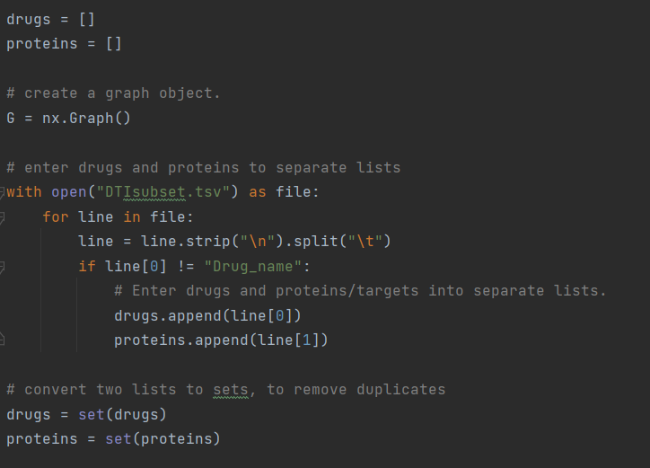When constructing the DTI network using NetworkX, save the drugs and targets/proteins into separate lists.
* 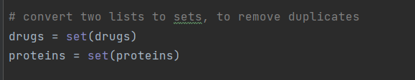Always, avoid duplicates when working with lists
* Use the drug-target lists to go through novel interaction pairs (avoid looking at already existing interactions) and calculate the CN score for each interaction.

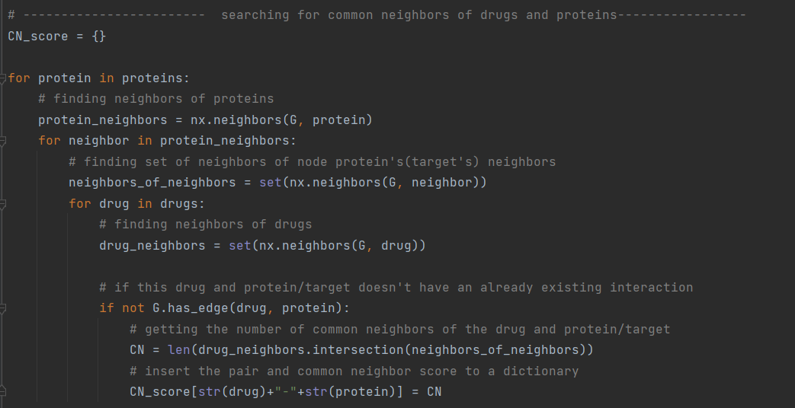

* You can save those interaction scores in a dictionary.

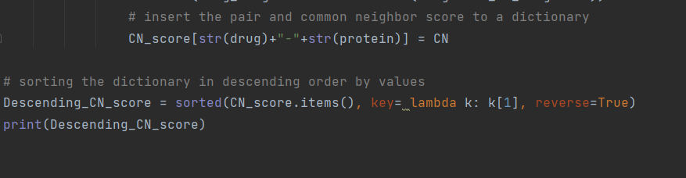

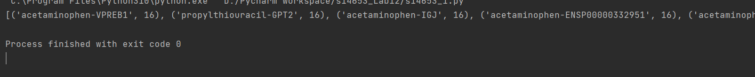

**References**

Lu, Yiding, Yufan Guo, and Anna Korhonen. "Link prediction in drug-target interactions network using similarity indices." *BMC bioinformatics* 18.1 (2017): 1-9.